**StatsLibrary User Manual**

A collection of Java based statistical functions.

Cachary Tolentino

CSCI-3327

**Table of Contents**

**Software Description3**

Detailed Description3.1

System Requirements3.2

**Installation Guide4**

**Class Overview7**

getMean Function7.1

getMedian Function7.2

bubbleSort Function7.3

getMode Function7.4

getStandardDeviation Function7.5

**Software Description**

A collection of Java based statistical functions.

**Detailed Description**

In the StatsLibrary class you can find a multitude of different statistical functions that can be used to calculate various formulas for a given set of inputs. You can find functions such as getMean, getMedian, and getMode which returns the mean, median, and mode. More functions can be found in the **Class Overview** section.

**System Requirements**

* A working device, primarily a desktop or laptop
* An IDE (ex: VSCode, Eclipse, etc…)
* Java JDK (Ver. 17 & up) & JRE (SE 17 & up)

**Installation Guide**

To begin using StatsLibrary, you will need to download two files. One is “StatsLibrary.java” and the other is “TestStatsLibrary.java” (optional).

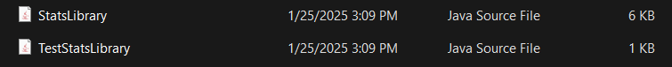

After downloading the files, simply move the files to the folder containing your project. Once done, you can open your preferred IDE (for this example we will be using VSCode). Then you can open the folder or the file itself within your IDE.

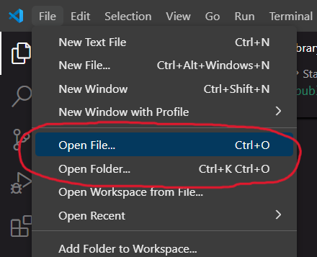

If you opened the folder containing the files then it should look similar to the image below.

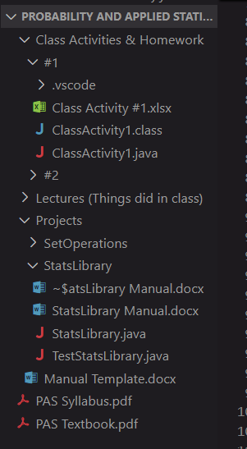

If you only imported the StatsLibrary file then you can simply start using the class within your own personal project. Otherwise, if you also imported the TestStatsLibrary, then you can open that file and run it.

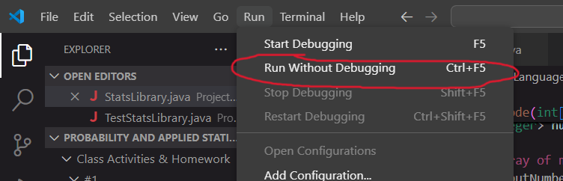

The result will be displayed on the console, unless there are graphical displays being run.

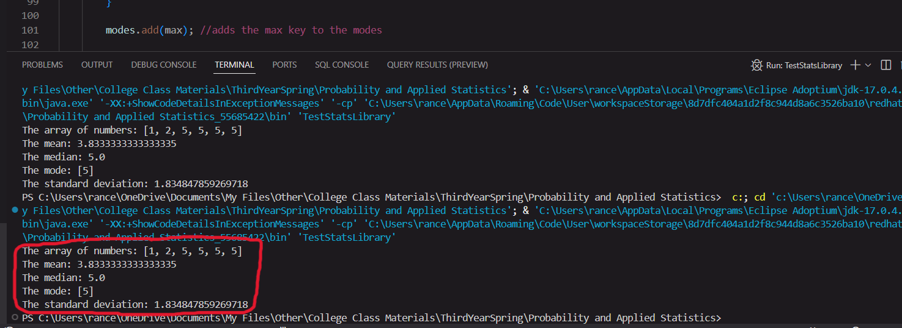

**Class Overview**

**getMean Function**

The getMean function is a function that takes in one **parameter** and returns a **double.** This function will return the mean of a given array of integers. One must pass an array of integers to use the function properly.

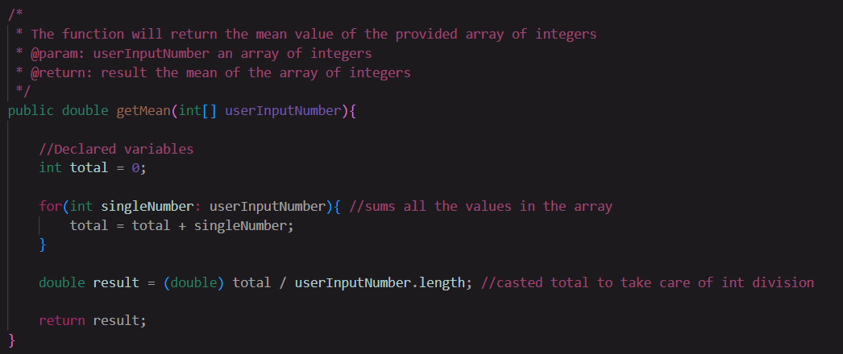

**getMedian Function**

The getMedian function is a function that takes in one **parameter** and returns a **double.** This function will return the median of a given array of integers. One must pass an array of integers to use the function properly. This function allows of odd or even amount of numbers within the array. This function is also implemented using bubbleSort as its sorting algorithm.

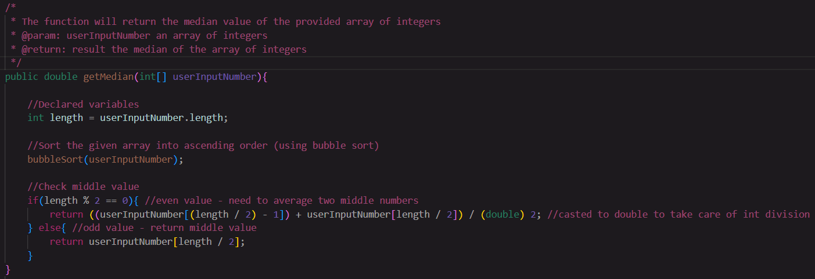

**bubbleSort Function**

The bubbleSort function is a function that takes no **parameters** and does not return any value**.** This function will sort a given array of integers into increasing order.

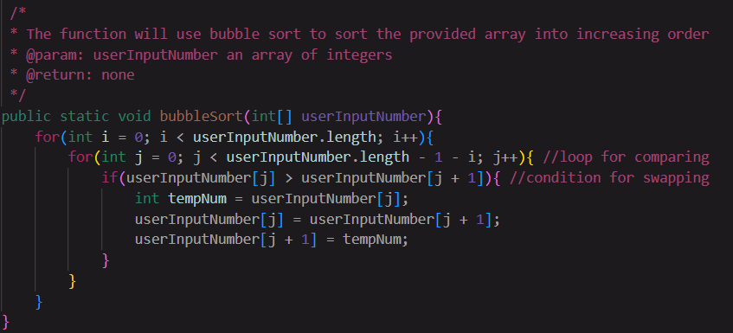

**getMode Function**

The getMode function is a function that takes in one **parameter** and returns a **Set of Integers.** This function will return the mode(s) of a given array of integers. One must pass an array of integers to use the function properly. This function uses a HashMap to find the mode.

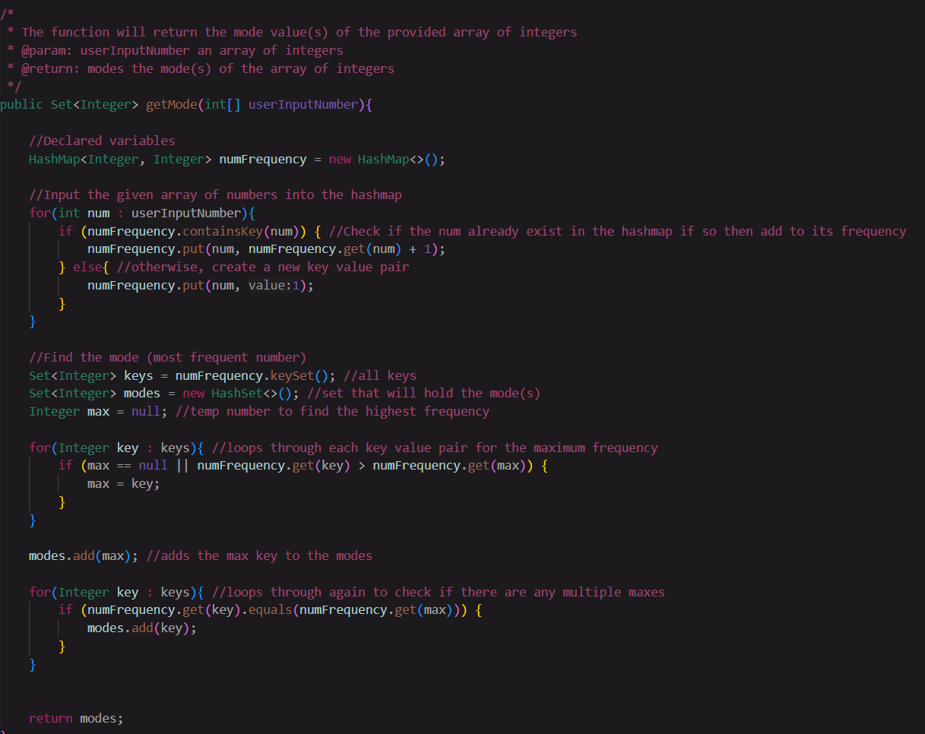

**getStandardDeviation Function**

The getStandardDeviation function is a function that takes in one **parameter** and returns a **double.** This function will return the sample standard deviation of a given array of integers. One must pass an array of integers to use the function properly.

